Project documentation

1. Project description

The data that was used in this project was gathered using a pair of Tobii eye-tracking glasses. The piece of data that was used more specifically so far was the so called “Gaze Position”, which is the exact location at which a person is looking in a specific frame.

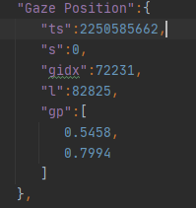

Figure 1 Gaze Position 2D

What we are trying to achieve with this piece of data is to figure out if the person is looking at the same object in successive frames, by checking if there are any correlations between these points. We can achieve this by using the K-means Clustering algorithm with our data set.

1. Project Implementation

The first step was to import the libraries needed:

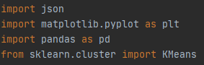

Figure 2 Libraries

The next step was to load our data:

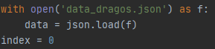

Figure 3 Loading JSON data

The chosen method for representing the data set was using a DataFrame.



Figure 4 This is a DataFrame

Here we can see a clear representation of our data being put in the DataFrame:

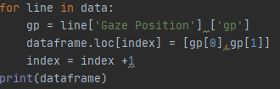

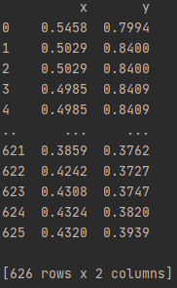

0 and 1 as in ‘gp[0]’ and ‘gp[1]’ are the corresponding keys of each coordinate therefore we can access them within our data set.

This is the same representation but for the “Gaze Position 3D” dataset:

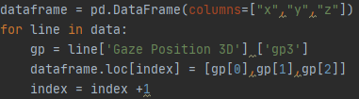

Figure 6 3D representation

The next step was to fit the data with the K-means clustering algorithm:



Figure 7 K-means clustering

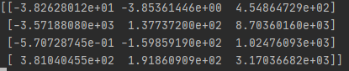

Figure 8 Centroids location in x, y, z

In the case of 3D representation, the number of clusters chosen was 4, as it was the most relevant for our dataset.

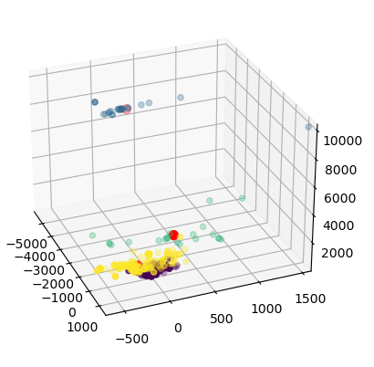

Figure 9 K-means in Gaze Position 3D